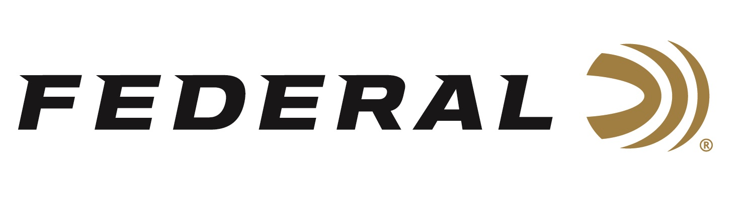

FOR IMMEDIATE RELEASE

Custom Gunworks owner Rob Roberts appears on Federal Ammunition’s “It’s Federal Season” Podcast

ANOKA, Minnesota – April 30, 2020 – When it comes to customizing a firearm, there are few gunsmiths more recognizable than Rob Roberts, owner of Rob Roberts Custom Gunworks. Roberts owns and operates a full line shop that performs custom gun work on shotguns and custom rifles. His unique business proposition includes building a choke specific to an individual shotgun based on a computer analysis.

Episode No. 7 - Customizing King
https://www.federalpremium.com/podcast.html

“Rob is one of the most passionate industry contributors,” says Jason Vanderbrink, President of Federal Ammunition. “He built his business on wanting to improve his customer’s experiences and performance plain and simple and you’ll hear that passion in this interview.” Roberts discusses how he got into the firearms business and the research and experiences he had that drove him to starting a business designed to optimize firearm performance.

In the Tech Talk segment, Federal goes inside the Custom Shop to meet with Dave Dellapaolera, one of highly skilled engineers operating the state-of-the-art workshop. Dellapaolera discusses the intricacies of the process to build the most consistent, accurate, and personalized ammunition in the world. Before signing off, find out what promotions are available for consumers and where consumers can meet with our ammunition team to talk all things ammunition. Look for more podcasts at www.federalpremium.com or where you find your favorite podcasts.

Federal ammunition can be found at dealers nationwide or purchased online direct from Federal. For more information on all products from Federal or to shop online, visit www.federalpremium.com.

Press Release Contact: JJ Reich
Senior Manager – Press Relations
E-mail: VistaPressroom@VistaOutdoor.com

About Federal Ammunition
Federal, headquartered in Anoka, MN, is a brand of Vista Outdoor Inc., an outdoor sports and recreation company. From humble beginnings nestled among the lakes and woods of Minnesota, Federal Ammunition has evolved into one of the world's largest producers of sporting ammunition. Beginning in 1922, founding president, Charles L. Horn, paved the way for our success. Today, Federal carries on Horn's vision for quality products and service with the next generation of outdoorsmen and women. We maintain our position as experts in the science of ammunition production. Every day we manufacture products to enhance our customers' shooting experience while partnering with the conservation organizations that protect and support our outdoor heritage. We offer thousands of options in our Federal Premium and Federal® lines-it's what makes us the most complete ammunition company in the business and provides our customers with a choice no matter their pursuit.

